长征精神的基本内涵是：

①把全国人民和中华民族的根本利益看得高于一切，坚定革命的理想和信念，坚信正义事业必然胜利的精神；

②为了救国救民，不怕任何艰难险阻，不惜付出一切牺牲的精神；

③坚持独立自主、实事求是，一切从实际出发的精神；

④顾全大局、严守纪律、紧密团结的精神；

⑤紧紧依靠人民群众，同人民群众生死相依、患难与共、艰苦奋斗的精神。

The basic connotations of the Long March Spirit are:

1. Placing the fundamental interests of the entire nation and Chinese people above all else, firm in revolutionary ideals and beliefs, and convinced of the inevitable victory of a just cause.
2. The spirit of fearing no difficulties or obstacles and being willing to sacrifice to save the country and its people.
3. Adhering to independence and self-reliance, seeking truth from facts, and starting from reality.
4. The spirit of considering the overall situation, strictly observing discipline, and maintaining close unity.
5. Relying closely on the people, sharing life and death, enduring hardships together, and striving tenaciously.

（一）精神内涵

[案例：长征中的雪山草地](https://mp.weixin.qq.com/s?__biz=MzU0NTUwNTM0Mw==&mid=2247489995&idx=1&sn=09db725a0ed7000580135c7cf66850e8&chksm=fb6ab09bcc1d398dce741201fdea4954820f7306cce53b61a555a4762e14fb27f95b69a3b2b6&scene=27)

红军在长征中克服了翻越终年积雪的大雪山、穿越茫茫草地等极端困难，展现了坚韧不拔的革命精神和大无畏的英雄气概，付出了巨大的牺牲，这些历史篇章永远铭记着他们不畏艰险、勇往直前的坚定信念。

**Example: Snowy Mountains and Grasslands in the Long March**

During the Long March, the Red Army overcame extreme difficulties such as crossing snow-capped mountains and vast grasslands, demonstrating indomitable revolutionary spirit and fearless heroism. They made great sacrifices, and these historical chapters forever commemorate their unwavering courage and determination.



[案例：遵义会议](https://baike.baidu.com/reference/64086/533aYdO6cr3_z3kATKKPmPj5YHvFM9msuLeCAOdzzqIP0XOpS57mFJg378cz-7lkGwaFs5YtR_RawLz7DEla6PMRd-kqRrEjmH_3UC2ajeO6)

遵义会议是长征精神的集中体现，它标志着中国共产党在独立自主、实事求是的思想指导下，确立了正确的领导和战略方针，从而在极其艰苦的条件下挽救了党、红军和中国革命，展现了坚定信念、团结协作和勇于担当的革命精神。

**Example: Zunyi Conference**

The Zunyi Conference is a concentrated embodiment of the Long March Spirit. It marked the establishment of correct leadership and strategic guidelines under the principles of independence and truth-seeking, saving the Party, the Red Army, and the Chinese revolution under extremely difficult conditions, showcasing firm beliefs, unity, cooperation, and courage.

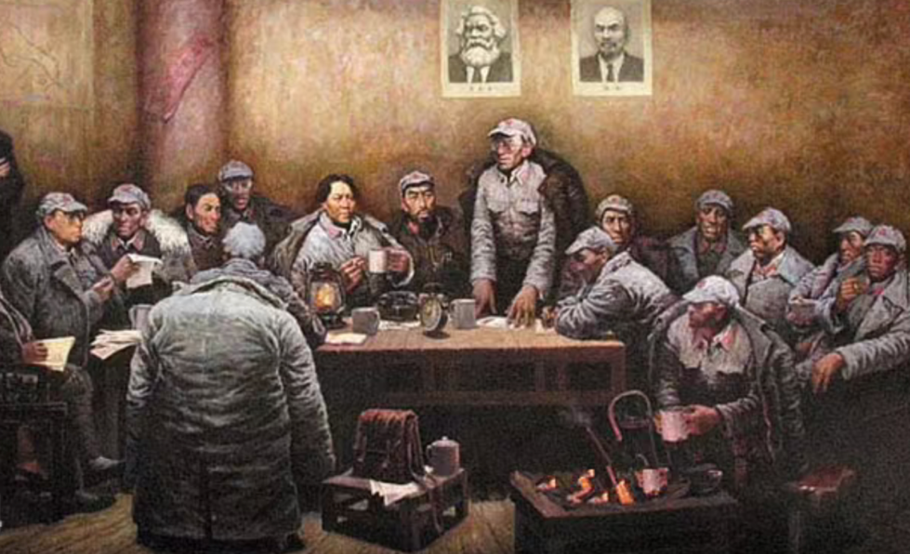

（二）时代价值

[案例：抗击疫情中的长征精神](https://m.gmw.cn/baijia/2020-03/18/33658862.html)

长征精神激励着医务人员在抗击疫情的战斗中展现出顽强拼搏和无私奉献的精神，这两者共同构筑了中国人民面对困难时的坚定信念和不屈斗志。

**Example: Long March Spirit in Fighting the Pandemic**

The Long March Spirit inspired medical staff to demonstrate tenacity and selfless dedication in the fight against the pandemic, building the Chinese people's firm conviction and unyielding spirit in the face of difficulties.

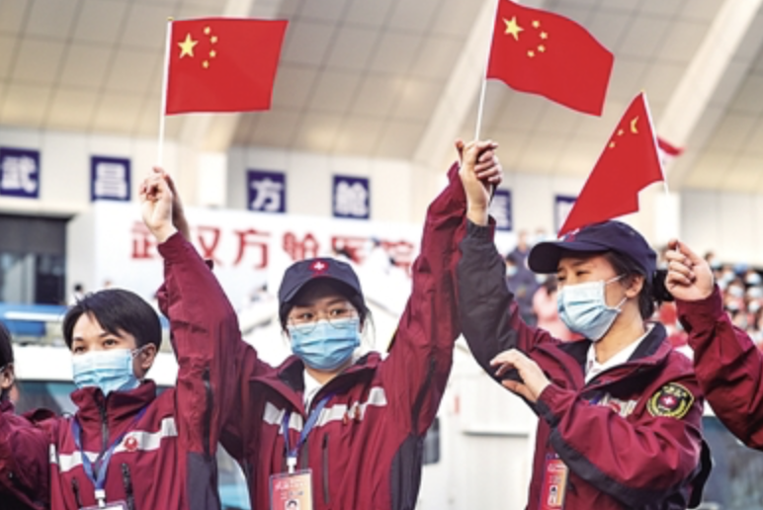

[案例：脱贫攻坚](https://news.cctv.com/2019/09/17/ARTILrxkIcFOf3oKZl09u20N190917.shtml)

长征精神，以其坚如磐石的理想信念、一往无前的英勇奋斗和坚韧不拔的刚强耐力，成为引领中国脱贫攻坚战役的强大动力。

**Example: Poverty Alleviation**

With its rock-solid ideals, heroic courage, and tenacious endurance, the Long March Spirit has become a powerful driving force leading China's battle against poverty.

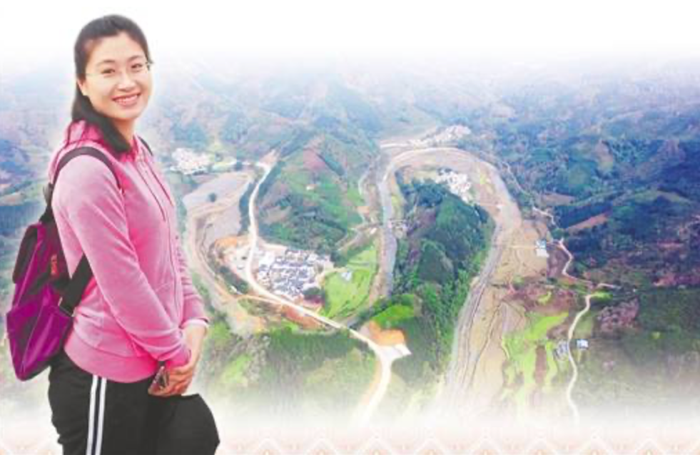

（三）传承与弘扬

[案例：长征文化教育](https://baijiahao.baidu.com/s?id=1808899618486383335&wfr=spider&for=pc)

贵州、江西、陕西三省联动，通过开学第一课《长征精神之美》跨越时空重温长征历史，利用现代科技手段如AI虚拟交互和虚拟现实技术，为全国中小学生提供了一场沉浸式红色教育体验，旨在弘扬长征精神。

**Example: Long March Cultural Education**

Guizhou, Jiangxi, and Shaanxi provinces jointly launched the first lesson of the school year, "The Beauty of the Long March Spirit," to revisit Long March history across time and space. Utilizing modern technologies like AI virtual interaction and virtual reality, they provided an immersive red education experience for primary and secondary school students nationwide, aiming to promote the Long March Spirit.

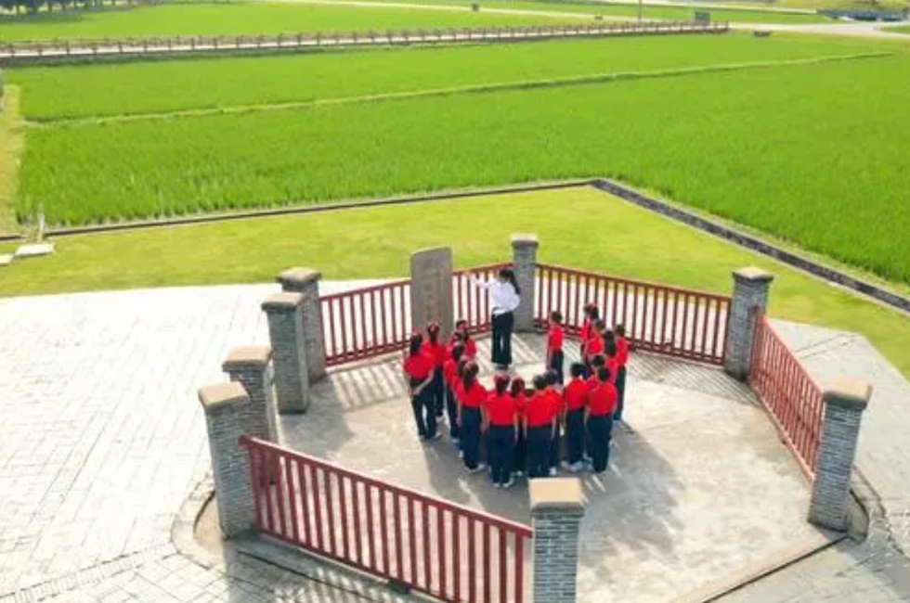

[案例：长征精神研讨会](https://sjc.shu.edu.cn/info/1009/3419.htm)

上海大学新闻传播学院成功举办了新时代弘扬传承长征精神主题研讨会，并启动了“长征精神”寻访实践项目，旨在通过实地走访和多元化传播，引导学生传承长征精神，为培养时代新人提供红色动力。

**Example: Long March Spirit Seminar**

The School of Journalism and Communication at Shanghai University successfully held a seminar on inheriting and promoting the Long March Spirit in the new era and launched the "Long March Spirit" exploration project. The aim is to guide students to inherit the Long March Spirit through field visits and diverse communication, providing red motivation for cultivating new generations.

